Mini Project 2 DA By SQL
Superstore Data Analysis & Database Normalization Project Documentation
Project Document & Analytical Report
Author: Mahmoud Ahmed Farag.
Present to: Dr. Alaa Abdelmoaty
Environment: SQL | MySQL Workbench 8.0 CE
Database Code: GitHub

1. Executive Summary & Overview
This project transforms an abnormalized, single-table Superstore sales dataset (mytable) into an enterprise-grade Star Schema relational database system. The primary goal was to eliminate data redundancy, enforce relational integrity, and optimize query performance to deliver business-critical analytics on revenue streams, customer behavior, product category performance, and operational efficiency.
2. Data Cleaning, Transformation & Normalization (ETL)
Data Ingestion & Cleaning:
- Date Parsing: Converted text-formatted order and shipping dates (MM/DD/YYYY) into MySQL native DATE formats using STR_TO_DATE.
- String Sanitization: Applied TRIM() logic on string fields to clean leading and trailing whitespace.
- Type Enforcement: Altered mytable column types to appropriate data types (VARCHAR, INT, DECIMAL, DATE) to prevent implicit conversions during migration.
Database Schema Normalization (3NF & Star Schema):
The flat architecture was decomposed into 4 Dimension Tables and 1 Fact Table:
- dim_customer: Stores unique customer profiles and market segments.
- dim_location: Auto-incremented spatial dimension breaking down geography by Country, Region, State, City, and Postal Code.
- dim_product: Categorical hierarchy storing Product Name, Category, and Sub-Category.
- dim_ship_mode: Normalizes logistic modes into lookup records.
- fact_sales: Central transaction table maintaining line-item metrics (sales, profit, quantity, discount) linked via Primary Key / Foreign Key constraints.
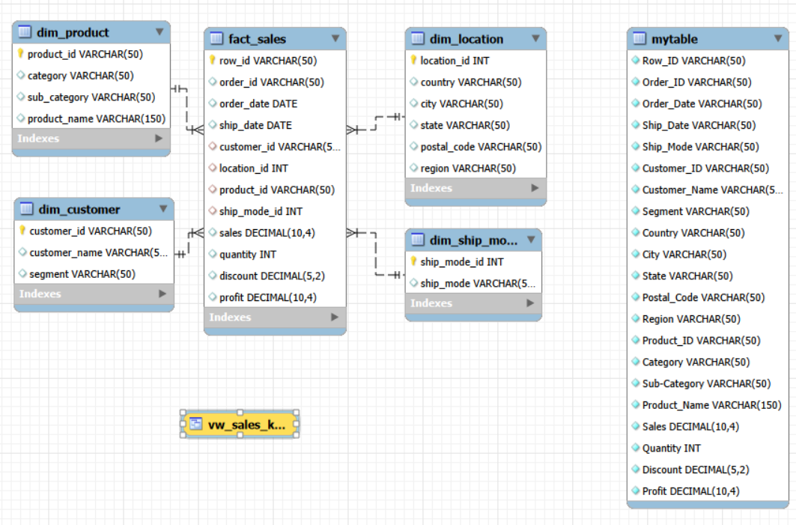
3. Analytical Queries & Key Business Findings
SQL Analytics:
- Order Level Detail: Relational JOIN retrieving customer names and product details per order.
- Category Profitability: Grouped aggregated revenue and profit metrics across high-level categories.
- Regional Revenue Breakdown: Measured sales contribution across geographical zones.
- Top Spenders: Identified top 3 high-value customers by total monetary spend using ORDER BY ... DESC LIMIT 3.
- Sub-Average Profit Identification: Evaluated loss-making or low-performing orders using nested subqueries filtering below mean profit.
- Profitability Categorization: Applied CASE logic classifying orders into 'Gain', 'Break Even', or 'Loss'.
- Sales Tiering: Categorized transaction volume into 'High', 'Medium', and 'Low' tiers via conditional logic.
- Shipping Duration: Calculated shipping turnaround speed (ship_date - order_date) per carrier mode.
- Top Product Performance (CTE): Utilized Common Table Expressions (WITH) to isolate top revenue-generating SKUs.
- Customer Behavior Metrics (CTE): Calculated customer-level lifetime value and cumulative profit margin.
- Segment Volume Analysis: Tracked unit quantities ordered across Consumer, Corporate, and Home Office segments.
- Monthly Sales Trends: Applied DATE_FORMAT to evaluate month-over-month sales trends (YY-MM).
- Discount vs. Profit Elasticity: Aggregated orders by discount percentage to analyze profitability impact.
- Geographic Density: Counted distinct orders across cities.
- Unprofitable Sub-Categories: Filtered loss-making sub-categories using the HAVING clause (SUM(profit) < 0).
Key Strategic Findings:
- Discount Impact: High discount rates adversely affect net profit margins without driving proportional unit volume growth.
- Loss-Leading Sub-Categories: Identified specific sub-categories running on negative aggregate profit margins that require pricing structure adjustment.
- Shipping Efficiency: Average fulfillment speeds vary significantly by shipping mode, providing baseline metrics for logistics SLAs.
4. Views, Stored Procedures & Database Optimization
Reusable Database Objects:
- KPI Summary View (vw_sales_kpis): A database view aggregating total revenue, net profit, total units sold, and average discount rate for executive dashboard consumption.
- Customer Report Stored Procedure (get_customer_report): A parameterized stored procedure that accepts a customer_id and outputs full purchase history and order breakdown.
Performance Optimization (Indexing):
- Created B-Tree secondary indexes on high-cardinality foreign keys and date filters (order_date, customer_id, product_id) inside fact_sales to eliminate full table scans during large-scale analytical queries.

